MGMS - Expenses

Functional Specification Document

Ver. 1.4

Version History
Version # | Date | Description
1.0 | 24-Oct-2010 | First draft
1.1 | 12-Nov-2010 | Added validation check error messages
1.2 | 29-Nov-2010 | Label change

Table of Contents

Version History 2
1 Introduction 4
1.1 Purpose 4
1.2 Scope 4
1.3 Assumptions 4
1.4 Constraints 5
2 Menu - Expenses 5
2.1 Record Expenses 5
2.2 View expenses for a period 7
2.3 View expenses head wise 8
3 Business Rules: 9
4 Status Messages 10

Introduction

Purpose

This document provides the requirements and functional specifications for the Expenses section of the Multisite Grant Management System project.
This is not a project plan or a design document. It is a guide for system architecture and development, not for phasing, timelines or deliverables.
Finally, this is a ‘living document’ and the specification will change, continuously, as the project proceeds. More details will be added and the existing information edited as the requirements, scenarios and use cases evolve in the course of the project.

Scope

This functionality shall enable the recording of expenses, project wise against the various account /sub account heads of the institution.
The details saved for each expense entry include: the amount, date of expense, grant allocation against which the expense may be put, associated account head name, mode of payment, payment details (DD/Cheque, bank details etc) and the user’s description, if any.
Each expense entry can be tracked through:
Option to view/edit Date wise expense list for user provided criteria of expense period
Option to view account head wise expense summary.
These expenses are added up for the utilization report.
Current scope does not include the source of fund used for paying off the expenses. There is only association with the grant allocation and therefore the project.

Assumptions

Since this module does not include accounting activities (at the moment), “expenses” record just the amount expended towards the particular project– it is assumed to be paid off at the time of incurring it (there is no account payable scenario).For the same reason, source of funds is not a concern while paying off. It is assumed that the allocation and resulting fund transfer will cover the expenses.
Currently provision will be made to allow user to record expense against a grant allocation, even if the associated fund has not been transferred to the institution. This is in effect, over utilization. Here, it is assumed that there may be contracts in which certain expenses are reimbursed by the grantor on submission of bills.
Fund transferred to grantee/sub grantee will not be considered as an expense. Only when the transferred fund is put into use by the grantee/sub grantee, it will be accounted as expense incurred towards the project.
Once the accounting module is in place, provision will be made to set the cost sharing account head and the associated source of fund for each project.

Constraints

The dependency of this module on the accounting module (which is in design mode) is a deciding factor for its further development.
Another constraint is the lack of clarity on the process flows followed by grant agencies in providing for grants and fund transfer. Information is required as to the policies with regard to expenses incurred before the project start date and after the end date respectively. So also for the items for which there is pre-paid fund and those which are cost –reimbursed. So certain validations have been avoided to enable flexibility for the user.

Menu - Expenses

Record Expenses

Each project in an institution incurs expenses in the nature of – salaries, materials and assets purchase etc. The expenses are categorized into account heads, for e.g., manpower, material purchase, finance etc
These are recorded here against the specific grant allocation which is expected to pay for the expenses.
For each project, it is required to view list of individual expenses as well as summarized account head wise expense for a period.

This expense DOES NOT include any funds transferred to grantee institutions of the user institution.

Screen & Control Description

Figure 1: Expense Entry
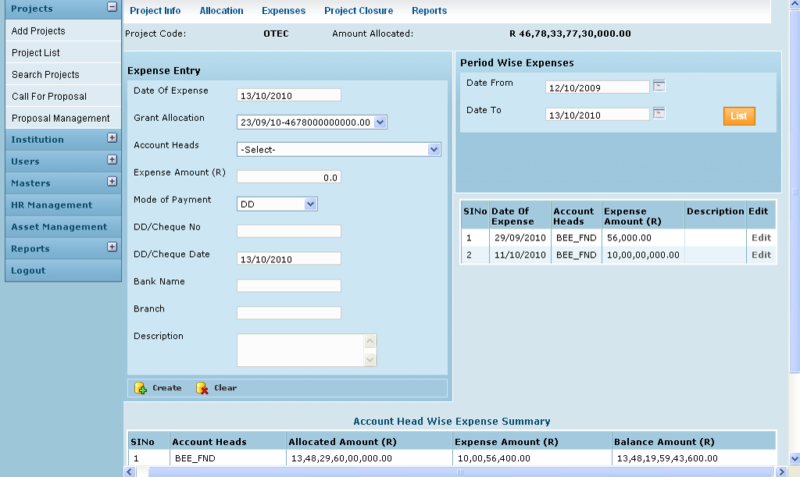

Field /Label | Input-Control | Data Type | Remarks / Edit Check
Project Code: | Auto populated | String
Amount Allocated | Auto populated | Number
Expense Entry
Date of Expense | Calendar | Date | Required
Grant Allocation: | Listbox | String | Required
Expense Amount (R) | Textbox | Number | Required
Account Heads | Listbox | String | Required
Mode of Payment | List box | String | Required
DD/Cheque No: | Textbox | String | Required unless Mode of payment is bank transfer/cash
DD/Cheque Date | Textbox | Date | Required unless Mode of payment is bank transfer/cash
Bank Name | Calendar | String | Required unless Mode of payment is cash
Branch | Textbox | String | Required unless Mode of payment is cash
Description | Textbox | String | Optional
Create | Button |  | Entries saved
Clear | Button |  | Entries are deleted from the fields.

Field /Label | Input-Control | Data Type | Remarks / Edit Check
Period wise Expenses
Date From | Calendar | Date | Required
Date To | Calendar | Date | Required
List | Button |  | On clicking, all the expenses incurred during the given period are listed in the table below
Sl No | Auto generated
Date of Expense | Auto populated
Account Head | Auto populated
Expense Amount | Auto populated
Description | Auto populated
Edit | Link |  | Opens the Edit Item Purchase window with the details corresponding to the line item populated in the fields

Field /Label | Input-Control | Data Type | Remarks / Edit Check
Account head wise expense summary
Sl No | Auto generated
Account Head | Auto populated
Allocated Amount | Auto populated |  | Sum of all allocated amounts to the account head for the project, to date
Expense Amount | Auto populated |  | Sum of all expense incurred towards the project, to date
Balance Amount | Auto populated |  | Allocated amount – Expense amount (to date)

View expenses for a period
Screen & Control Description

Individual expense items are listed out with corresponding account head name for a given period (start end date). The Date of expense is the search criteria
Figure 2: Expense List
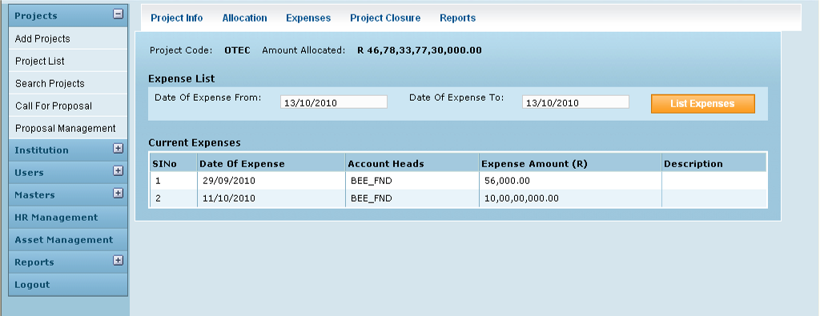

Field /Label | Input-Control | Data Type | Remarks / Edit Check
Project Code: | Auto populated | String
Amount Allocated: | Auto populated | Number | Amount allocated by the grantor
Expense List
Date of Expense from: | Calendar | Date | User Input –search criteria. Validation: This should be earlier than the Date of Expense to
Date of Expense to: | Calendar | Date | User Input –search criteria Validation: This should be later than the Date of Expense from
List Expenses | Button |  | On clicking , gives the list of expenses and details
Current Expenses
Sl No | Auto increment populated
Date of Expense | Auto populated | Date
Account Heads | Auto populated | String
Expense Amount (R) | Auto populated | Number
Description | Auto populated | String

View expenses head wise

As the name suggests, account head wise summed up expense amount is displayed for selected account head. By selecting “All” , the total expenses for all account heads is shown.
Currently, the balance amount is calculated by deducting expenses from the allocated amount

Screen & Control Description

Figure 3: Summary of Expenses
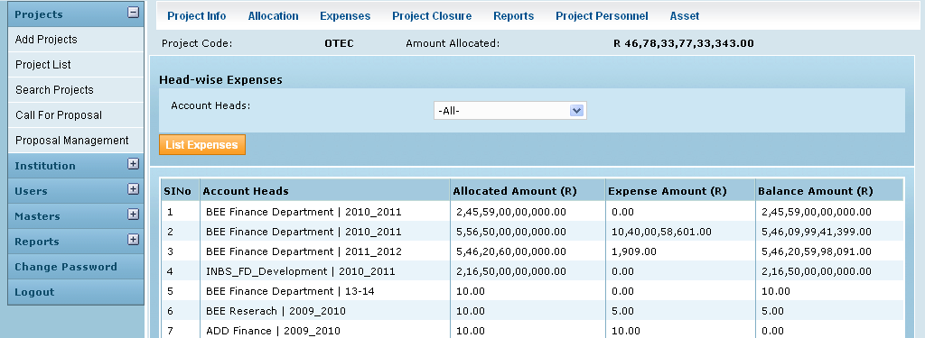

Field /Label | Input-Control | Data Type | Remarks / Edit Check
Project Code: | Auto populated | String
Amount Allocated: | Auto populated | Number | Amount allocated by the grantor
Head-wise Expenses
Account Heads: | Listbox | String | Lists all the account heads associated with the project and also the option “All” which includes all the account heads
List Expenses | Button |  | On clicking, displays the details of the individual expenses for the selected account head in the table below
Sl No | Auto generated
Account Heads | Auto populated | String
Allocated Amount (R) | Auto populated | calculated | Sum of all allocations made by the grantor towards this project in the particular account head.
Expense Amount (R) | Auto populated | calculated | Sum of all expenses incurred towards this project by the user institution and paid for from this account head. This does not include funds transferred to sub awardees.
Balance Amount (R) | Auto populated | calculated | Allocated Amount - Expense Amount

Business Rules:

Expenses are recorded against a specific grant allocation. It is not necessary that the funds required be already available i.e. over utilization is possible. And can be paid for once the fund is transferred.
Expense cannot be recorded if an allocation has not been made for a particular project.
Expense has to be assigned to an account head. So it cannot be recorded for an account head if an allocation has not been made for that particular account head
The date of Expense has to lie between the recorded Project Start and End dates.

Future Scope
A future requirement is for cost reimbursement kind of payment where in the fund is available post expense and therefore, expense may not be associated with an allocation at the time of recording it.

Another future requirement is for expense to be paid for by a source which is not the grantor – it could be a loan from an external agency or out of pocket of the user institution itself (cash account, bank account etc).

Since “funds transferred” is not included in the calculations, “balance amount” does not give the correct idea of the actual balance money available for further spending. This needs to be taken care of.

Reports should be able to group expense already paid for in cash, check, DD etc , accounts payable advance deposits etc for the specific project. It should also be possible to group expenses paid for by grant, loan and out-of-pocket.

Status Messages

Sl No | Status Message
1 | Created Successfully
2 | Updated Successfully
3 | Deleted Successfully
4 | The Requested Record Not Found
5 | The Record can't be deleted, Already in use
6 | The Record Already Exists
7 | Please Enter a valid email address
8 | You can not delete yourself, please login as another admin and try again
9 | Expense Request not found
10 | Requested fund is available
11 | Requested fund is not available
12 | Please enter Proper Amount
13 | Please select Account Head
14 | Please select Mode Of Payment
15 | Please enter DD/Cheque No
16 | Please enter Bank Name
17 | Please enter Bank Branch
18 | Date of Expense To must be later than Date of Expense From

